**WEEK 7**

**EXERCISE 1**

**PROGRAM**

**IndianPlayers,js**

import React from 'react';

function IndianPlayers() {

  const team = ['Virat', 'Rohit', 'Dhoni', 'Bumrah', 'Hardik', 'Gill'];

  const oddPlayers = team.filter((_, index) => index % 2 !== 0);

  const evenPlayers = team.filter((_, index) => index % 2 === 0);

  const T20players = ['Suryakumar', 'Kohli'];

  const RanjiTrophy = ['Prithvi Shaw', 'Mayank Agarwal'];

  const mergedPlayers = [...T20players, ...RanjiTrophy];

  return (

    <div>

      <h2>Odd Team Players:</h2>

      <ul>{oddPlayers.map((player, i) => <li key={i}>{player}</li>)}</ul>

      <h2>Even Team Players:</h2>

      <ul>{evenPlayers.map((player, i) => <li key={i}>{player}</li>)}</ul>

      <h2>Merged Players (T20 + Ranji Trophy):</h2>

      <ul>{mergedPlayers.map((player, i) => <li key={i}>{player}</li>)}</ul>

    </div>

  );

}

export default IndianPlayers;

**ListofPlayers.js**

import React from 'react';

function ListofPlayers() {

  const players = [

    { name: 'Virat', score: 85 },

    { name: 'Rohit', score: 45 },

    { name: 'Dhoni', score: 95 },

    { name: 'Bumrah', score: 60 },

    { name: 'Hardik', score: 75 },

    { name: 'Rahul', score: 67 },

    { name: 'Gill', score: 90 },

    { name: 'Ashwin', score: 58 },

    { name: 'Jadeja', score: 80 },

    { name: 'Shami', score: 40 },

    { name: 'Pant', score: 73 },

  ];

  const filteredPlayers = players.filter(player => player.score >= 70);

  return (

    <div>

      <h2>All Players:</h2>

      <ul>

        {players.map((player, index) => (

          <li key={index}>{player.name} - {player.score}</li>

        ))}

      </ul>

      <h2>Filtered Players (Score ≥ 70):</h2>

      <ul>

        {filteredPlayers.map((player, index) => (

          <li key={index}>{player.name} - {player.score}</li>

        ))}

      </ul>

    </div>

  );

}

export default ListofPlayers;

**App.js**

import React from 'react';

import './App.css';

import ListofPlayers from './ListofPlayers';

import IndianPlayers from './IndianPlayers';

function App() {

  const flag = true; // change to false to switch component

  return (

    <div className="App">

      {flag ? <ListofPlayers /> : <IndianPlayers />}

    </div>

  );

}

export default App;

**OUTPUT**

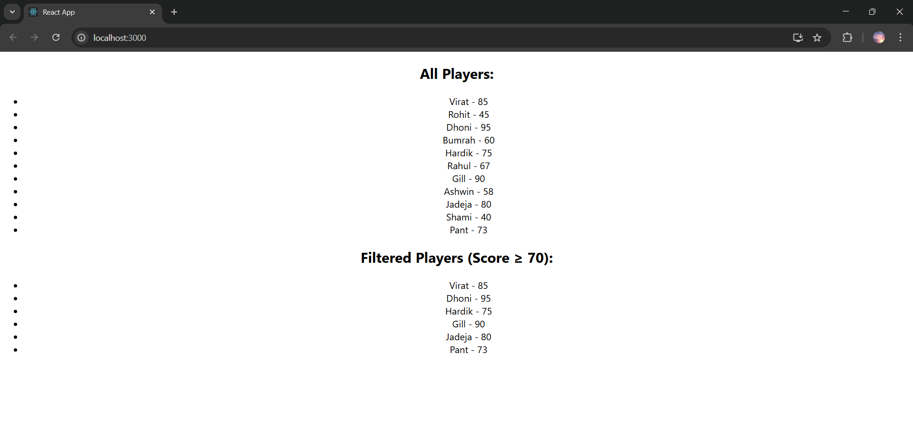

**App.js**

import React from 'react';

import './App.css';

import ListofPlayers from './ListofPlayers';

import IndianPlayers from './IndianPlayers';

function App() {

  const flag = false; // change to false to switch component

  return (

    <div className="App">

      {flag ? <ListofPlayers /> : <IndianPlayers />}

    </div>

  );

}

export default App;

**OUTPUT**

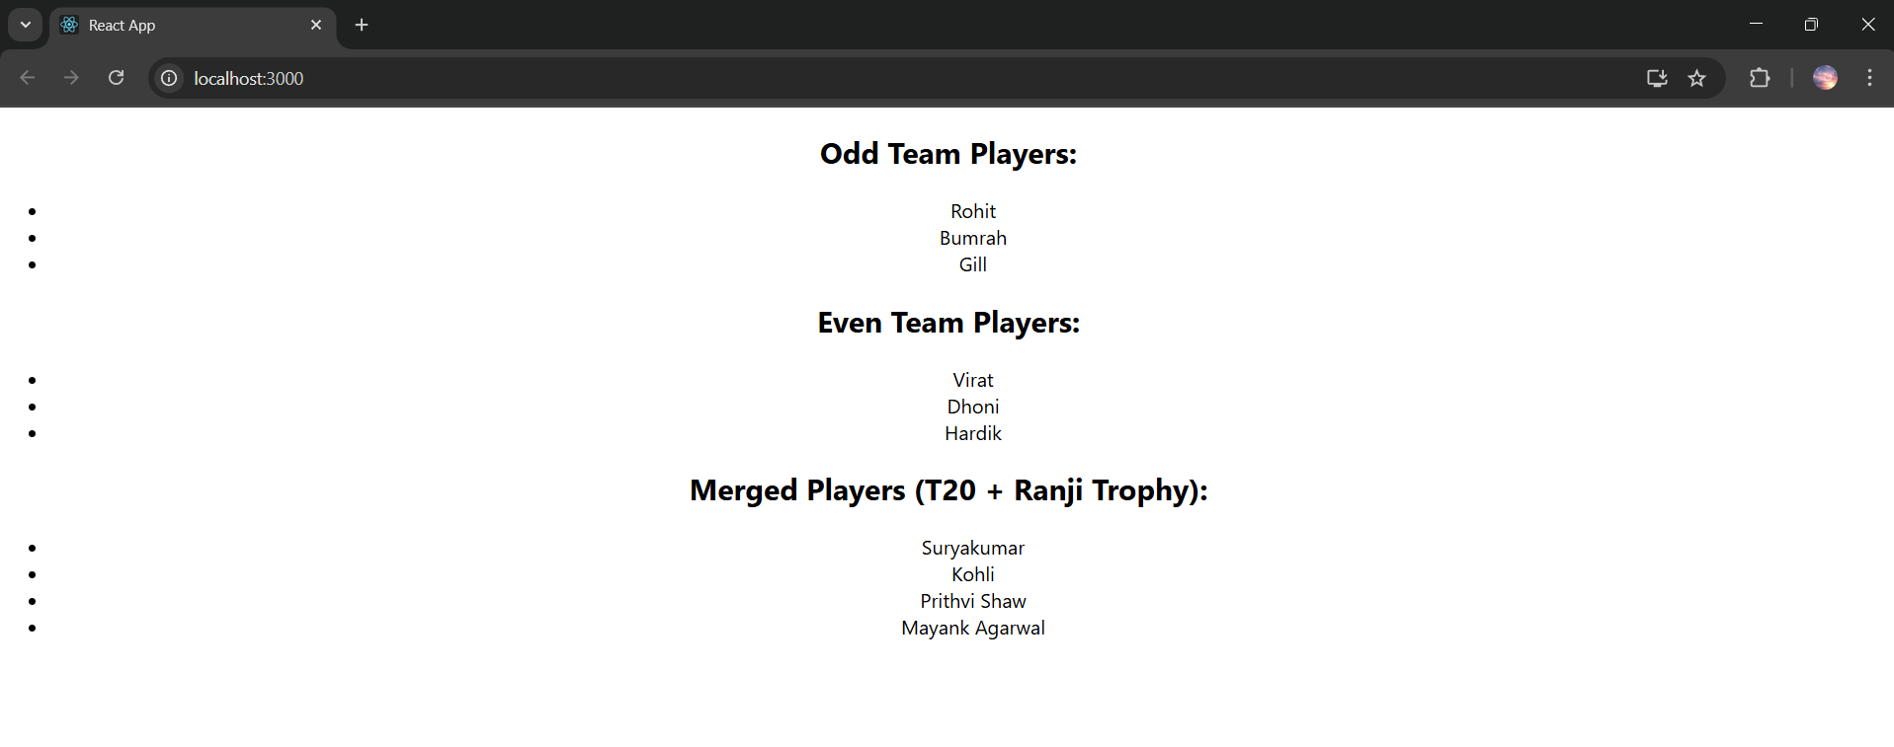

**EXERCISE 2**

**OUTPUT**

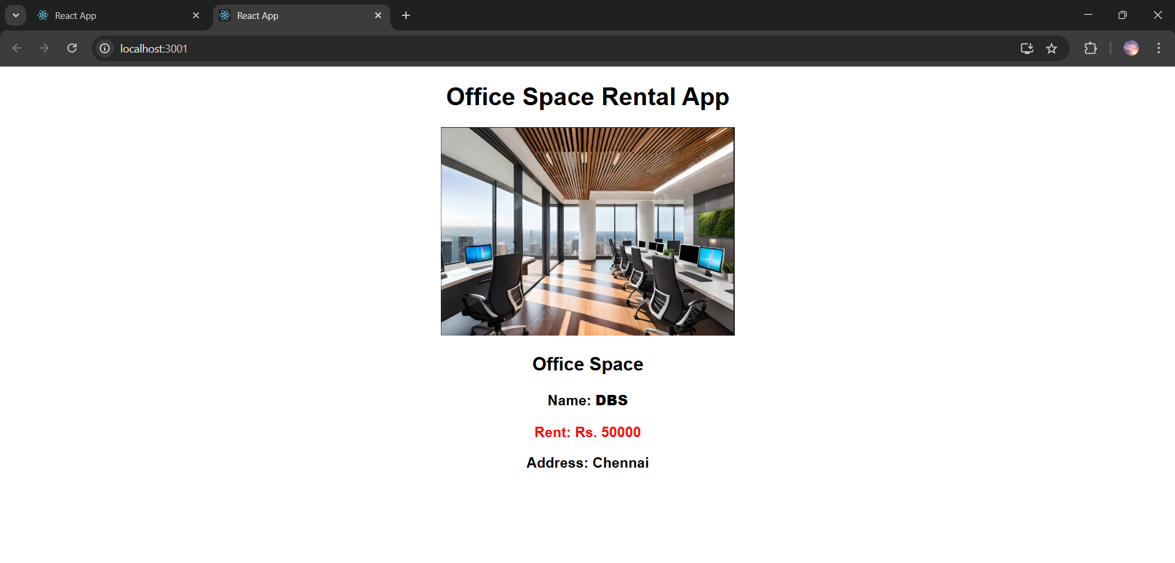

**EXERCISE 3**

**OUTPUT**

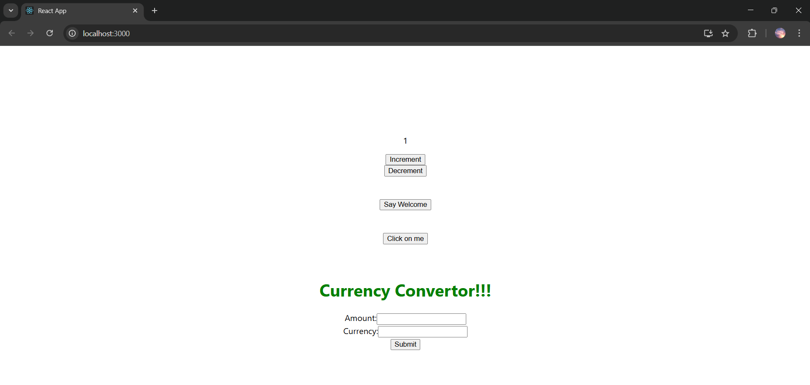

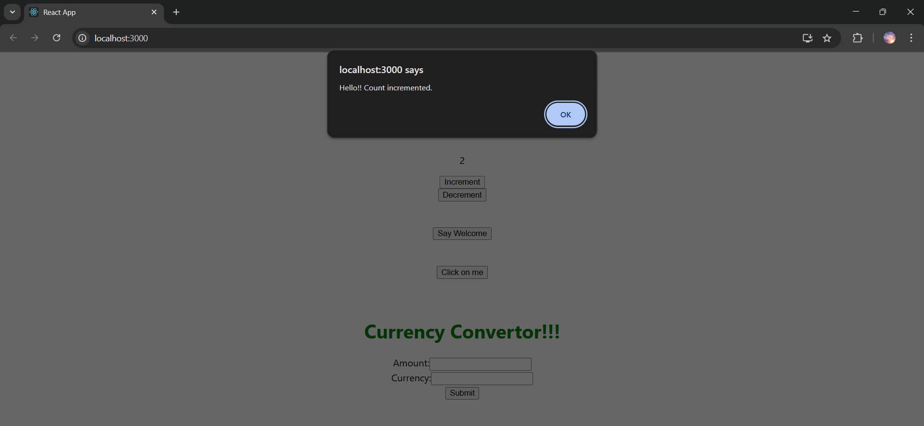

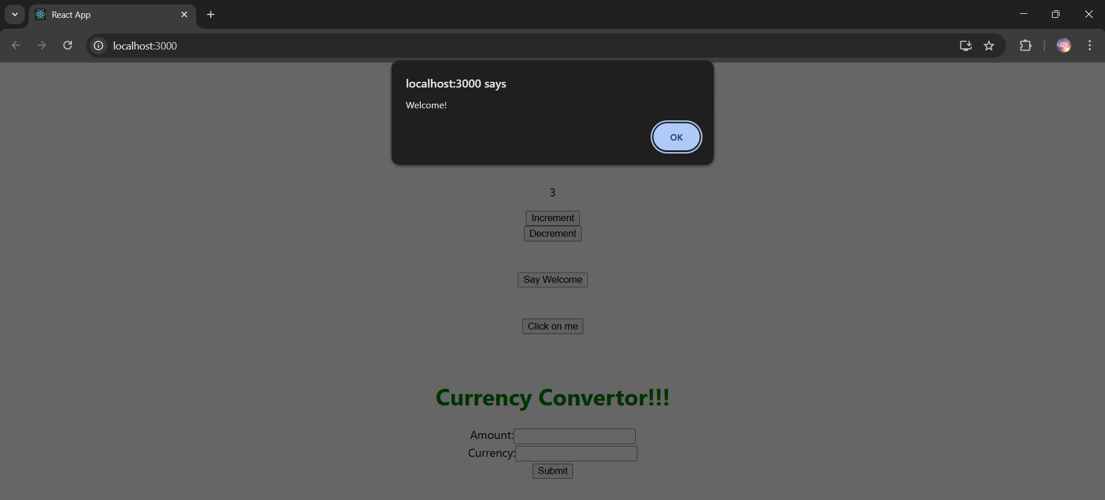

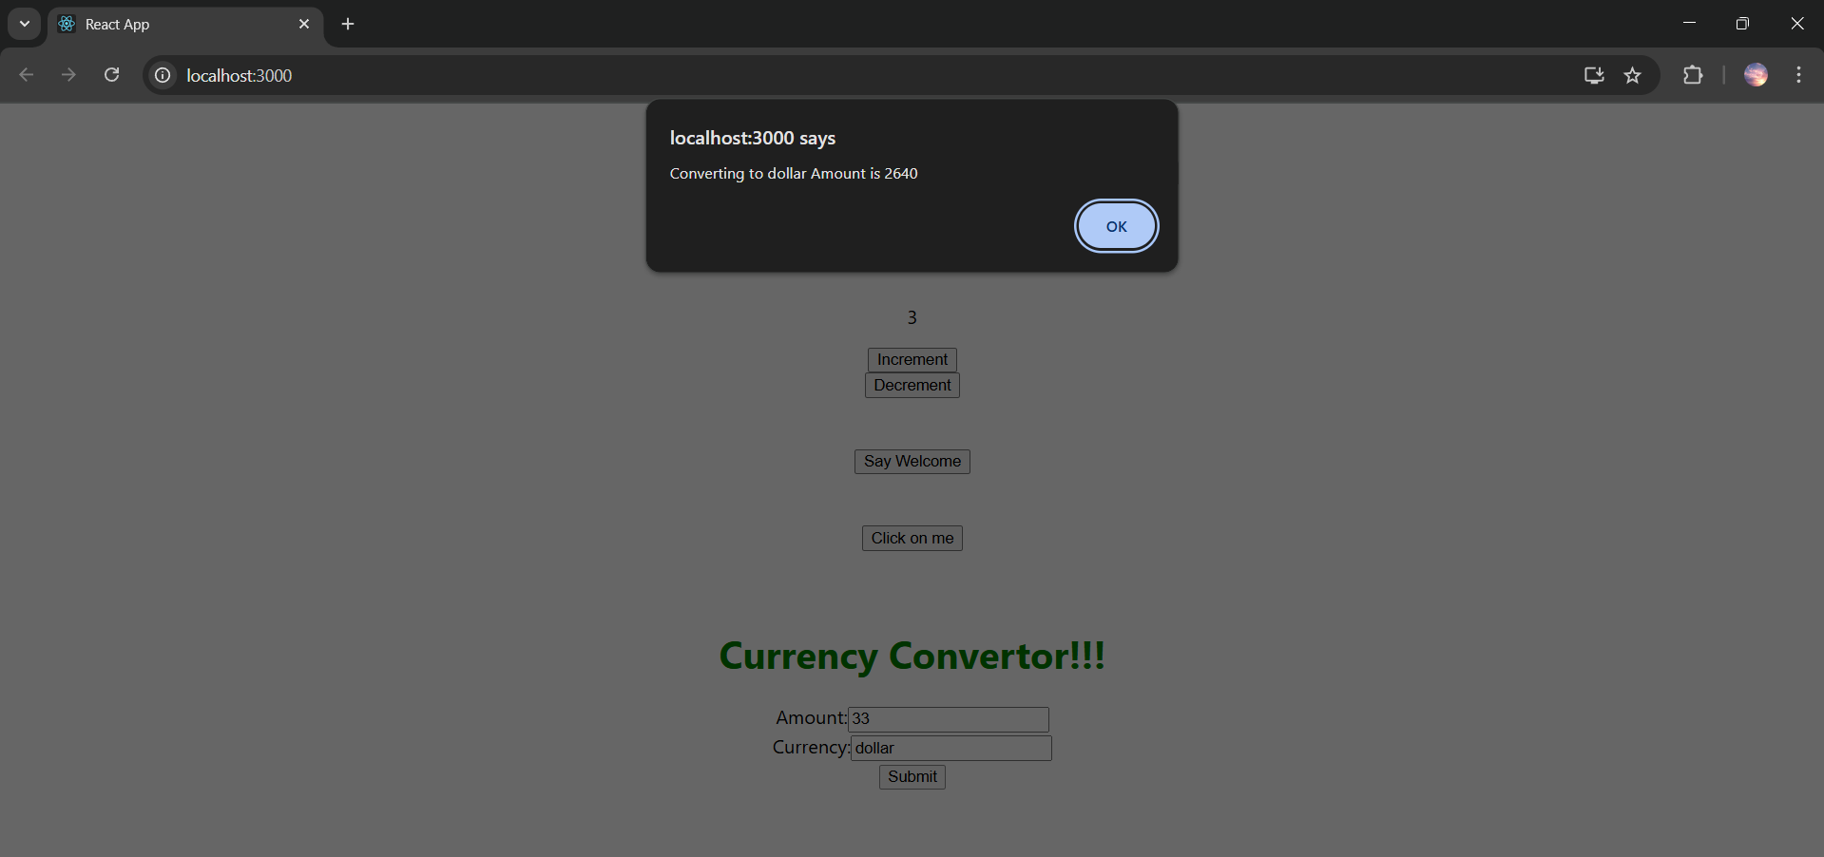

**EXERCISE 4**

**OUTPUT**

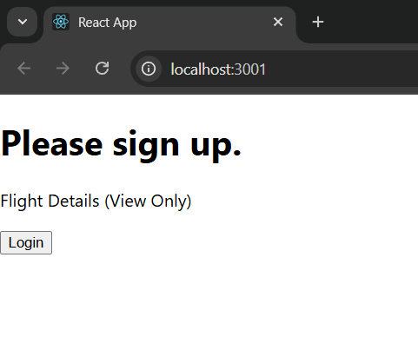

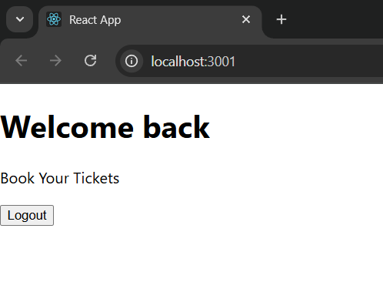

**EXERCISE 5**

**OUTPUT**

